Assignment No. 1

Program Code:
# Library Borrowing Record Management System from statistics import mean, mode
# Sample data
# Dictionary: member_name -> number_of_books_borrowed members_borrow = {
"Amit": 5,
"Priya": 3,
"Rohan": 0,
"Sneha": 2,
"Vikas": 8,
"Meena": 0,
"Tara": 3
}
# Dictionary: book_name -> number_of_times_borrowed books_borrow = {
"Python Basics": 10,
"Data Science 101": 7,
"Machine Learning": 12,
"AI Revolution": 5,
"Deep Learning": 3
}
# 1. Compute the average number of books borrowed by all library members average_books = mean(members_borrow.values())
# 2. Find the book with the highest and lowest number of borrowings most_borrowed_book = max(books_borrow, key=books_borrow.get) least_borrowed_book = min(books_borrow, key=books_borrow.get)
# 3. Count the number of members who have not borrowed any books no_borrow_members = sum(1 for x in members_borrow.values() if x == 0) # 4. Display the most frequently borrowed book (mode of borrow counts) borrow_counts = list(books_borrow.values()) most_frequent_borrow_count = mode(borrow_counts)
frequent_books = [book for book, count in books_borrow.items() if count == most_frequent_borrow_count]
# Display Results
print("===== Library Borrowing Summary =====")
print(f"Average number of books borrowed by members: {average_books:.2f}") print(f"Most borrowed book: {most_borrowed_book} ({books_borrow[most_borrowed_book]} times)")
print(f"Least borrowed book: {least_borrowed_book} ({books_borrow[least_borrowed_book]} times)")
print(f"Number of members with zero borrowings: {no_borrow_members}") print(f"Most frequently borrowed book(s): {', '.join(frequent_books)} (Borrowed {most_frequent_borrow_count} times)")

Output:
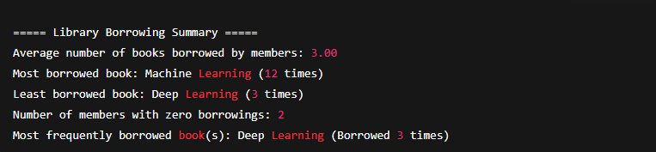

Assignment No. 2

Program Code:
# E-commerce Customer Account Search System # Linear Search Function
def linear_search(customer_ids, target): for i in range(len(customer_ids)):
if customer_ids[i] == target:
return i # Return the index if found return -1 # Not found
# Binary Search Function
def binary_search(customer_ids, target): low = 0
high = len(customer_ids) - 1 while low <= high:
mid = (low + high) // 2
if customer_ids[mid] == target: return mid # Found
elif customer_ids[mid] < target: low = mid + 1
else:
high = mid - 1 return -1 # Not found
# Sample list of customer account IDs
customer_ids = [1001, 1005, 1010, 1020, 1050, 1075, 1100]
# Input: Customer ID to search target_id = 1050
print("===== E-commerce Customer Search =====") print("Customer IDs:", customer_ids) print(f"Searching for Customer ID: {target_id}\n") # Perform Linear Search
linear_result = linear_search(customer_ids, target_id) if linear_result != -1:
print(f"✅ Linear Search: Customer ID {target_id} found at position
{linear_result}") else:
print(f"❌ Linear Search: Customer ID {target_id} not found")
# Perform Binary Search (requires sorted list) binary_result = binary_search(customer_ids, target_id) if binary_result != -1:
print(f"✅ Binary Search: Customer ID {target_id} found at position
{binary_result}") else:
print(f"❌ Binary Search: Customer ID {target_id} not found")

Output:
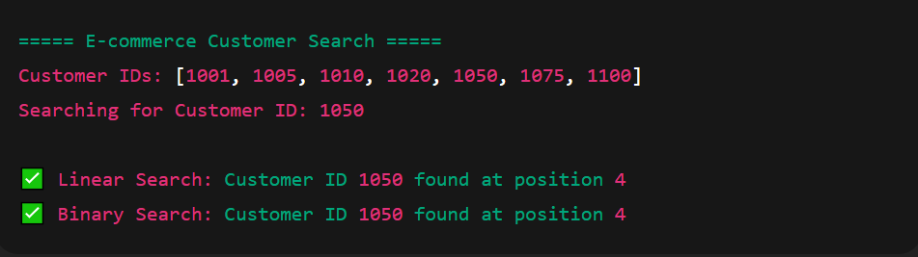

Assignment No. 3

Program Code:
# Real-time Undo/Redo System using Stack class TextEditor:
def init (self):
self.document = "" # Current state of the document self.undo_stack = [] # Stores previous document states self.redo_stack = [] # Stores undone states for redo
def make_change(self, new_text):
"""Add a new change to the document.""" self.undo_stack.append(self.document) # Save current state for

undo

self.document += new_text # Apply the new change self.redo_stack.clear() # Clear redo stack (new

change made)
print(f"📝 Change made: '{new_text}'") def undo(self):
"""Undo the most recent change.""" if not self.undo_stack:
print("⚠ Nothing to undo.")
return
self.redo_stack.append(self.document) # Save current state for

redo

self.document = self.undo_stack.pop() # Revert to previous state print("↩ Undo performed.")

def redo(self):
"""Redo the most recently undone change.""" if not self.redo_stack:
print("⚠ Nothing to redo.")
return
self.undo_stack.append(self.document) # Save current state for

undo

self.document = self.redo_stack.pop() # Reapply the undone change print("↪ Redo performed.")

def display(self):
"""Display the current document content.""" print(f"📄 Current Document: '{self.document}'")
# ----- DEMONSTRATION -----
editor = TextEditor() # Make changes
editor.make_change("Hello") editor.display() editor.make_change(" World") editor.display() editor.make_change("!!!") editor.display()

# Undo last two actions editor.undo() editor.display() editor.undo() editor.display()
# Redo one action editor.redo() editor.display()
# Make another new change editor.make_change(" Python") editor.display()

Output:
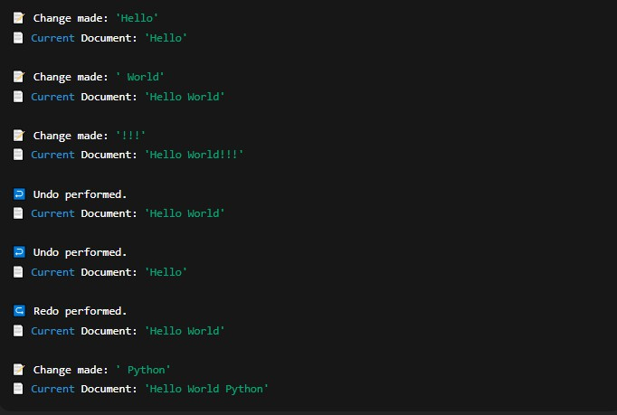

Assignment No. 4

Program Code:
# Real-Time Event Processing System using Queue from collections import deque
class EventQueue:
def init (self):
self.queue = deque() # Initialize an empty queue

def add_event(self, event_name): """Add a new event to the queue.""" self.queue.append(event_name)
print(f"📥 Event added: '{event_name}'")

def process_event(self):
"""Process (and remove) the oldest event in the queue.""" if not self.queue:
print("⚠ No events to process.")
return
event = self.queue.popleft() print(f"⚙ Processed event: '{event}'")

def display_events(self):
"""Display all events currently in the queue.""" if not self.queue:
print("🟢 No pending events.")
else:
print("📋 Pending events:", list(self.queue))

def cancel_event(self, event_name):
"""Cancel an event if it's still in the queue.""" if event_name in self.queue:
self.queue.remove(event_name)
print(f"❌ Event canceled: '{event_name}'")
else:
print(f"⚠ Event '{event_name}' not found or already
processed.")

# ----- DEMONSTRATION -----
system = EventQueue()

# Add some events system.add_event("User Login") system.add_event("File Upload")

system.add_event("Payment Processing") system.add_event("Email Notification")

# Display all pending events system.display_events()

# Process one event system.process_event() system.display_events()

# Cancel one pending event system.cancel_event("Payment Processing") system.display_events()

# Process remaining events system.process_event() system.process_event() system.display_events()

Output:
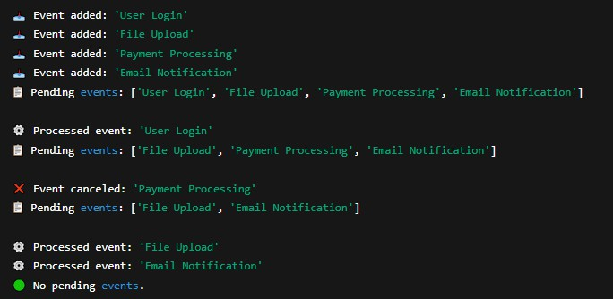

Assignment No. 5

Program Code:
# Student Record Management System using Doubly Linked List

class Node:
"""Node to store student data"""
def init (self, roll_no, name, marks): self.roll_no = roll_no
self.name = name self.marks = marks self.next = None self.prev = None

class StudentList:
"""Doubly Linked List implementation""" def init (self):
self.head = None

def add_student(self, roll_no, name, marks): """Add a new student record at the end""" new_node = Node(roll_no, name, marks)
if not self.head: self.head = new_node
print(f"✅ Added: {name} (Roll No: {roll_no}, Marks: {marks})")
return
temp = self.head while temp.next:
temp = temp.next temp.next = new_node new_node.prev = temp
print(f"✅ Added: {name} (Roll No: {roll_no}, Marks: {marks})")

def delete_student(self, roll_no):
"""Delete student record by roll number""" temp = self.head
while temp:
if temp.roll_no == roll_no: if temp.prev:
temp.prev.next = temp.next else:
self.head = temp.next if temp.next:
temp.next.prev = temp.prev
print(f"🗑 Deleted record of Roll No: {roll_no}") return

temp = temp.next
print(f"⚠ Record with Roll No {roll_no} not found.")

def update_student(self, roll_no, new_name=None, new_marks=None): """Update student details"""
temp = self.head while temp:
if temp.roll_no == roll_no: if new_name:
temp.name = new_name if new_marks is not None:
temp.marks = new_marks
print(f"✏ Updated Roll No: {roll_no} → Name: {temp.name},
Marks: {temp.marks}")
return
temp = temp.next
print(f"⚠ Record with Roll No {roll_no} not found.")

def search_student(self, roll_no):
"""Search and display a student record""" temp = self.head
while temp:
if temp.roll_no == roll_no:
print(f"🔍 Found: Roll No: {temp.roll_no}, Name:
{temp.name}, Marks: {temp.marks}")
return
temp = temp.next
print(f"⚠ Record with Roll No {roll_no} not found.")

def sort_records(self, key="marks", ascending=True): """Sort records by roll number or marks"""
if not self.head:
print("⚠ No records to sort.")
return

swapped = True while swapped:
swapped = False temp = self.head while temp.next:
first = temp.marks if key == "marks" else temp.roll_no second = temp.next.marks if key == "marks" else
temp.next.roll_no
if (ascending and first > second) or (not ascending and first < second):

temp.roll_no
temp.roll_no, temp.next.roll_no = temp.next.roll_no, temp.name, temp.next.name = temp.next.name, temp.name

temp.marks
temp.marks, temp.next.marks = temp.next.marks,

swapped = True temp = temp.next

order = "ascending" if ascending else "descending" print(f"✅ Records sorted by {key} in {order} order.")

def display_records(self): """Display all student records""" if not self.head:
print("⚠ No records available.")
return
print("\n📋 Student Records:") temp = self.head
while temp:
print(f" Roll No: {temp.roll_no} | Name: {temp.name} | Marks:
{temp.marks}")
temp = temp.next print()

# ----- DEMONSTRATION -----
students = StudentList()

# Add students students.add_student(101, "Amit", 85)
students.add_student(102, "Sneha", 90)
students.add_student(103, "Ravi", 78)
students.add_student(104, "Priya", 92)

# Display all students.display_records()

# Update a record students.update_student(103, new_marks=82)

# Search a student students.search_student(102)

# Sort by marks (descending) students.sort_records(key="marks", ascending=False) students.display_records()

# Delete a record students.delete_student(101) students.display_records()

Output:
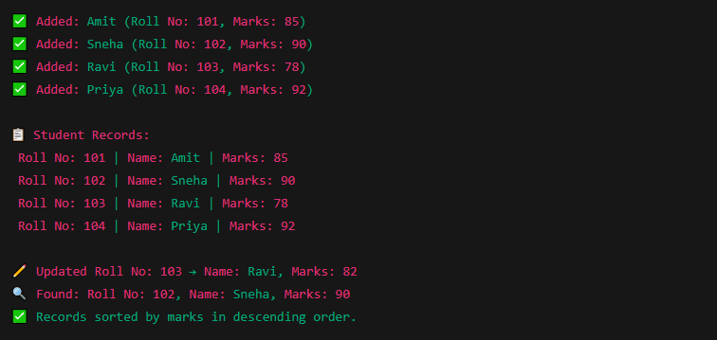
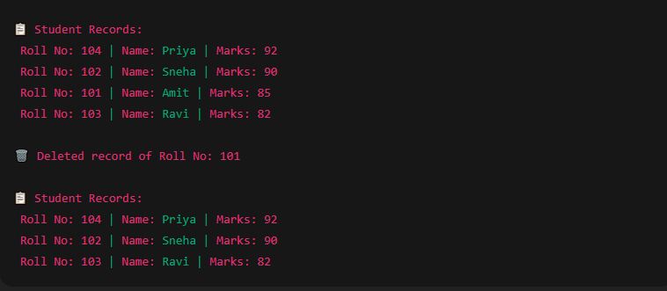

Assignment No. 6

Program Code:
# Selection Sort Implementation def selection_sort(arr):
n = len(arr)
for i in range(n): min_index = i
for j in range(i + 1, n):
if arr[j] < arr[min_index]: min_index = j
arr[i], arr[min_index] = arr[min_index], arr[i] return arr
# Bubble Sort Implementation def bubble_sort(arr):
n = len(arr)
for i in range(n - 1):
for j in range(n - i - 1): if arr[j] > arr[j + 1]:
arr[j], arr[j + 1] = arr[j + 1], arr[j]
return arr
# Example Employee Salaries (Floating-Point Numbers)
salaries = [45000.75, 52000.25, 61000.50, 49000.00, 73000.80,
88000.20, 65000.10, 41000.00, 56000.45, 79000.35]

print("Original Salaries:") print(salaries)
# Sorting Using Selection Sort
selection_sorted = selection_sort(salaries.copy()) print("\nSalaries Sorted (Selection Sort):") print(selection_sorted)
# Sorting Using Bubble Sort
bubble_sorted = bubble_sort(salaries.copy()) print("\nSalaries Sorted (Bubble Sort):") print(bubble_sorted)
# Display Top 5 Highest Salaries
top_five = sorted(salaries, reverse=True)[:5] print("\nTop 5 Highest Salaries:")
for i, salary in enumerate(top_five, start=1): print(f"{i}. ₹{salary:.2f}")

Output :
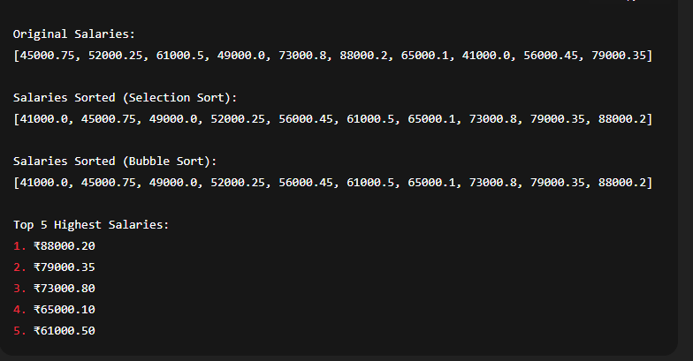

Assignment No. 7

Program Code:
# Hash Table implementation using Chaining and Division Method

class HashTable:
def init (self, size=10): self.size = size
self.table = [[] for _ in range(size)] # Each slot holds a list for chaining

def hash_function(self, key):
"""Hash function using division method""" return key % self.size

def insert(self, key, value):
"""Insert key-value pair into hash table""" index = self.hash_function(key)
# Check if key already exists → update it for pair in self.table[index]:
if pair[0] == key: pair[1] = value
print(f"✏ Updated key {key} with new value '{value}'")
return
# Otherwise, insert new key-value pair self.table[index].append([key, value])
print(f"✅ Inserted: ({key}, '{value}') at index {index}")

def search(self, key):
"""Search for a key in the hash table""" index = self.hash_function(key)
for pair in self.table[index]: if pair[0] == key:
print(f"🔍 Found: Key {key} → Value '{pair[1]}'")
return pair[1] print(f"⚠ Key {key} not found.") return None

def delete(self, key):
"""Delete a key-value pair""" index = self.hash_function(key) for pair in self.table[index]:
if pair[0] == key: self.table[index].remove(pair)
print(f"🗑 Deleted key {key} from index {index}")
return
print(f"⚠ Key {key} not found for deletion.")

def display(self):
"""Display the entire hash table"""
print("\n📋 Hash Table State:") for i in range(self.size):
print(f"Index {i}: {self.table[i]}") print()

# ----- DEMONSTRATION -----
hash_table = HashTable()

# Insert key-value pairs hash_table.insert(10, "Alice")
hash_table.insert(25, "Bob") # Collision with 5 (25 % 10 = 5)
hash_table.insert(15, "Charlie") # Collision with 5 (15 % 10 = 5) hash_table.insert(30, "David")
hash_table.insert(7, "Eva") hash_table.display()
# Search for some keys hash_table.search(25) hash_table.search(99) # Not present

# Delete a key hash_table.delete(15) hash_table.display()

# Insert new key to test reuse
hash_table.insert(35, "Frank") # Collision again with 5 hash_table.display()

Output :
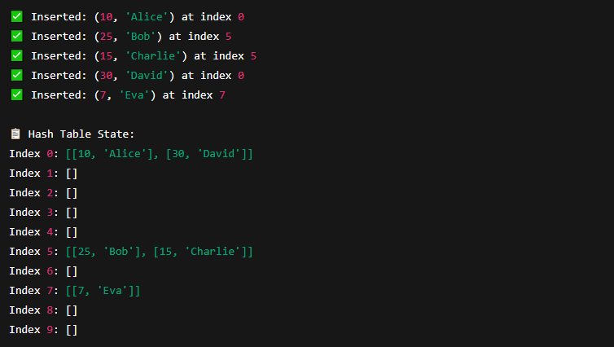
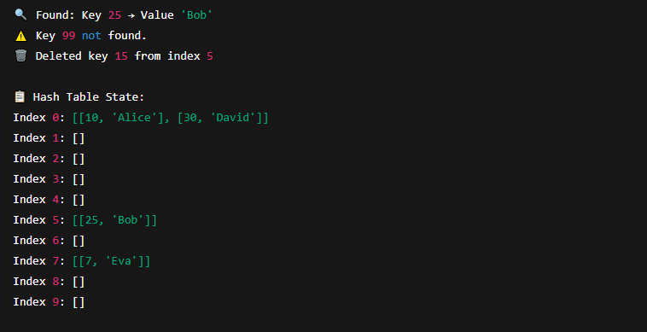

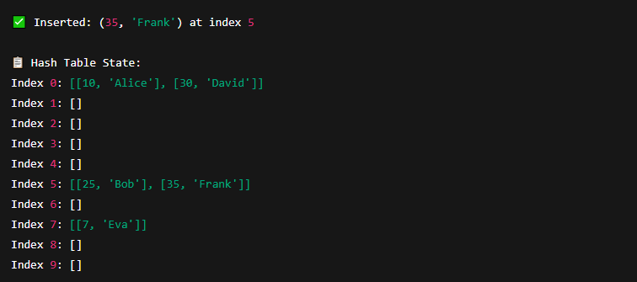

Assignment No. 8

Program Code:
# Graph Traversal for City Locations (BFS & DFS) from collections import deque
#
# PART 1 — DFS using Adjacency Matrix #
def dfs_using_matrix(matrix, start, visited, nodes): """Recursive DFS traversal using adjacency matrix""" index = nodes.index(start)
visited[index] = True print(start, end=" ")

for j in range(len(matrix)):
if matrix[index][j] == 1 and not visited[j]: dfs_using_matrix(matrix, nodes[j], visited, nodes)
#
# PART 2 — BFS using Adjacency List #
def bfs_using_list(adj_list, start):
"""BFS traversal using adjacency list""" visited = set()
queue = deque([start]) visited.add(start)

while queue:
node = queue.popleft() print(node, end=" ")

for neighbor in adj_list[node]: if neighbor not in visited:
visited.add(neighbor) queue.append(neighbor)
#
# DEMONSTRATION #
# Example city locations (Nodes) locations = ["A", "B", "C", "D", "E"]

# Adjacency Matrix Representation for DFS # A B C D E
# A 0 1 1 0 0
# B 1 0 1 1 0
# C 1 1 0 0 1
# D 0 1 0 0 1

# E 0 0 1 1 0

adj_matrix = [
[0, 1, 1, 0, 0],
[1, 0, 1, 1, 0],
[1, 1, 0, 0, 1],
[0, 1, 0, 0, 1],
[0, 0, 1, 1, 0]
]

# Adjacency List Representation for BFS adj_list = {
"A": ["B", "C"],
"B": ["A", "C", "D"],
"C": ["A", "B", "E"],
"D": ["B", "E"],
"E": ["C", "D"]
}

# Start traversal from location A start_node = "A"

print("===== DFS Traversal (Adjacency Matrix) =====") visited_nodes = [False] * len(locations) dfs_using_matrix(adj_matrix, start_node, visited_nodes, locations)

print("\n\n===== BFS Traversal (Adjacency List) =====") bfs_using_list(adj_list, start_node)

Output :
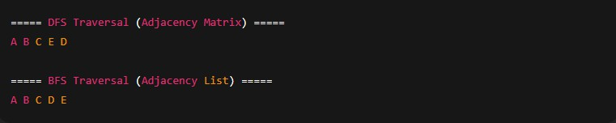

Assignment No. 9

Program Code:
import heapq

#
# Function: Dijkstra's Algorithm #
def dijkstra(graph, start):
# Initialize distances with infinity
distances = {node: float('inf') for node in graph} distances[start] = 0 # Distance to start node is 0

# Priority queue to get the next node with minimum distance pq = [(0, start)] # (distance, node)

while pq:
current_distance, current_node = heapq.heappop(pq)

# Skip if we've already found a shorter path if current_distance > distances[current_node]:
continue

# Check neighbors
for neighbor, weight in graph[current_node]: distance = current_distance + weight

# If a shorter path is found
if distance < distances[neighbor]: distances[neighbor] = distance heapq.heappush(pq, (distance, neighbor))

return distances

#
# Example Graph (City Map) #
# Each edge represents time (in minutes) between locations graph = {
'Shop': [('A', 10), ('B', 3)],
'A': [('Shop', 10), ('B', 1), ('C', 2)],
'B': [('Shop', 3), ('A', 1), ('C', 8), ('D', 2)],
'C': [('A', 2), ('B', 8), ('D', 7), ('E', 5)],
'D': [('B', 2), ('C', 7), ('E', 1)],
'E': [('C', 5), ('D', 1)]
}

# Starting point (Pizza Shop) start_location = 'Shop'

#
# Run Dijkstra's Algorithm #
shortest_times = dijkstra(graph, start_location)

#
# Display Results #
print("===== Minimum Time to Deliver Pizzas from Shop =====") for location, time in shortest_times.items():
print(f"To reach {location}: {time} minutes")

Output :
